Derby Safeguarding Adults Board and
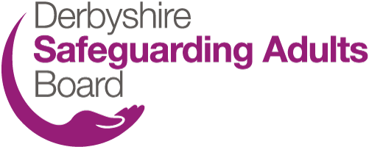
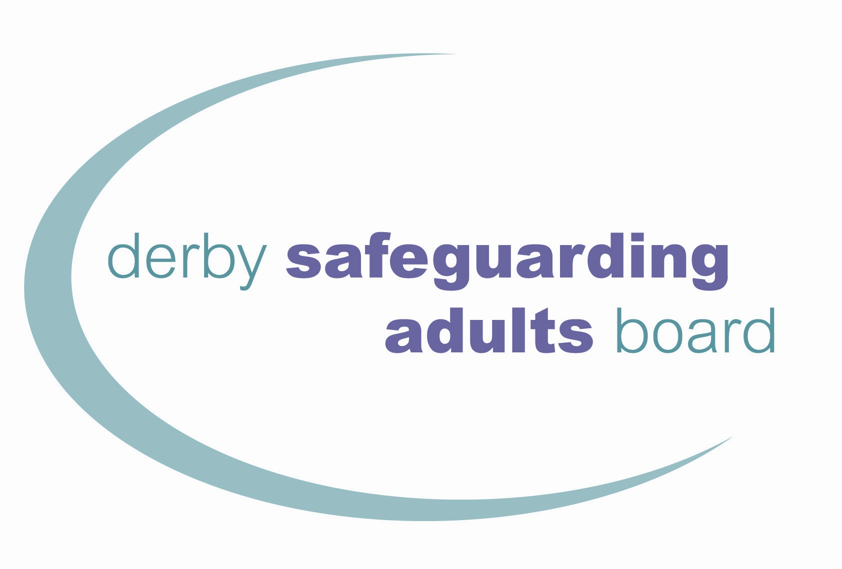
Derbyshire Safeguarding Adults Board
Referral Form

When completing the referral form please consult the Derby and Derbyshire Safeguarding Adults Procedures and also refer to the Derbyshire and Derby SABs Adults Safeguarding Decision-Making Guidance below:

Derby and Derbyshire SAB Safeguarding Adults Decision Making Guidance

Where appropriate, please share the Easy Read – Safeguarding Adults What to Expect Leaflet with the Adult or the representative. This leaflet is available on the DSAB Resource page and can be accessed in a range of different languages.

FOR ALL SAFEGUARDING REFERRALS PLEASE TELEPHONE the relevant local authority to make the referral before submitting this form.

For Derby City, please call 01332 642855 or 01332 956606 outside of office hours.

For Derbyshire County, please contact Call Derbyshire on 01629 533190 or 01629 532600 outside of office hours.

The email addresses below are secure. However, you should seek assurance from your IT team that you have the correct security to email securely to ‘gov.uk’ addresses. If in doubt, please send an encrypted email. Please note: these email inboxes are not monitored out of hours.

Derby City | AdultsMASH@derby.gov.uk
Amber Valley Area (Ripley, Alfreton, Belper) | ASCH.BSAmbervalley@derbyshire.gov.uk
Bolsover Area (Clowne, Whitwell) | ASCH.BSBolsover@derbyshire.gov.uk
Chesterfield Area | ASCH.BSChesterfield@derbyshire.gov.uk
Erewash (Long Eaton, Ilkeston) | ASCH.BSErewash@derbyshire.gov.uk
High Peak Area (Glossop, Buxton, Matlock) | ASCH.BSHighpeak@derbyshire.gov.uk
North East Area (Clay Cross, Dronfield, Eckington) | ASCH.BSNorthEast@derbyshire.gov.uk
South Dales Area (Ashbourne, Swadlincote, Shardlow, Willington, Hilton, Etwall) | ASCH.BSSouthDales@derbyshire.gov.uk

Please note: sending person identifiable information using the above email addresses may amount to a breach of Data Protection legislation if you do not send from a secure email address to a secure email address.

ALL QUESTIONS MUST BE COMPLETED IN FULL TO ALLOW ASSESSMENT OF RISK
Any incomplete forms made by professional agencies will not be accepted by the Local Authority and will be reported to referring agency safeguarding leads for quality assurance.

- DETAILS OF THE ADULT
Name of relevant adult: Click or tap to enter text. |  | Date of birth: Click or tap to enter a date.
Gender: Choose an item. |  | If Other, please state: Click or tap to enter text.
Ethnicity: Choose an item. |  | If Other Ethnic Group, please state: Click or tap to enter text.
Address: Click or tap to enter text. |  | Telephone number: Click or tap to enter text.
Present location of the adult, if different from above: Click or tap to enter text.
If known, does the adult have a funded package of support? (Please include who is funding the care package if known)? Click or tap to enter text.
Has the referral been discussed with the adult/representative? Choose an item. | If ‘No’, why not?  Click or tap to enter text.
Have you considered the adult’s capacity (Mental Capacity Act) to make a decision about the safeguarding referral? Choose an item.
If ‘No’, why not? Click or tap to enter text.
If ‘Yes’, what was the outcome? Choose an item.
Has the adult consented to the referral? Choose an item.
If ‘No’, why not? Click or tap to enter text.

Where the adult has not consented to the referral, what legal grounds are there to override consent?  Consent should be sought by explaining to the adult the benefits of sharing information which is relevant and proportionate to the safeguarding concerns, and that sharing information will enable all agencies to work together with the adult to create a safety plan | ☐  ☐ | Not applicable  Lacks capacity to consent (MCA 2005)
 | ☐ | Prevention and Investigation of Crime (CDA 1998)
 | ☐ | Prevent serious harm/distress/threat to life (GDPR 2016)
 | ☐ | Risk to other people
 | ☐ | Risk to children (CA 1989)
 | ☐ | The adult is under duress or coercion
 | ☐ | Domestic abuse meets MARAC criteria
 | ☐ | Alleged abuser needs care and support/may be at risk
 | ☐ | Staff are implicated
 | ☐ | Court order/other legal authority
 | ☐ | Other: Click or tap to enter text.
Is the adult able to independently represent their views and wishes? |  |  | Choose an item.
Would the adult like someone to support or represent them? If so, please provide details: |  |  | Click or tap to enter text.
Where the adult consents to the referral what do they want to happen as an outcome of the referral? |  |  | Click or tap to enter text.
Where there is a representative supporting the adult, is the representative aware of the safeguarding concerns? |  |  | Choose an item.
Has the ‘Safeguarding What to expect Leaflet’ been shared with the Adults/representative? |  |  | Choose an item.
Does the adult need a referral to formal advocacy support or services? |  |  | Choose an item.
If yes, has a referral already been made to a formal advocacy provider. Please provide details. |  |  | Click or tap to enter text.

- STATUTORY SAFEGUARDING CRITERIA
What care and support needs does the adult have?  - For example, does the adult have any medical conditions or disabilities such as learning disability, dementia, physical disability, mental ill health etc. Please describe how these conditions impact the adult’s day-to-day life.  - Are there any conditions which impact on the person’s ability to make decisions for themselves? If you have completed a capacity assessment, please provide more information here.  - Please also explain whether the adult has experienced any trauma, do they have any leaving care status, previous experience of abuse, experiencing coercion or control, etc.  - Please also state if the adult is a carer for someone else | Click or tap to enter text.
Reflecting on the care and support needs above, how do these needs prevent the adult keeping themself safe? | Click or tap to enter text.

- CATEGORY OF ALLEGED ABUSE/RISK OF ABUSE
☐ | Physical | ☐ | Sexual | ☐ | Psychological/emotional
☐ | Financial/material | ☐ | Discriminatory | ☐ | Domestic abuse
☐ | Sexual exploitation | ☐ | Neglect/acts of omission | ☐ | Modern slavery
☐ | Organisational | ☐ | Self-neglect

- DOES THE ABUSE/NEGLECT INVOLVE ANY OF THE FOLLOWING FACTORS?
☐ | Ageism | ☐ | Anti-social behaviour | ☐ | Caring responsibilities
☐ | Criminal exploitation | ☐ | Cross-border/county lines issues | ☐ | Cuckooing
☐ | Disability | ☐ | Female Genital Mutilation | ☐ | Forced marriage
☐ | Gender discrimination | ☐ | Hate crime | ☐ | Hoarding
☐ | Homelessness | ☐ | Honour-based violence | ☐ | Mate crime
☐ | No recourse to public funds | ☐ | Poverty/cost of living | ☐ | Pregnancy/maternity
☐ | Racism | ☐ | Radicalisation | ☐ | Religious intolerance
☐ | Rough sleeping | ☐ | Sexual orientation/Homophobia | ☐ | Substance misuse
☐ | Transphobia | ☐ | Not Known | ☐ | Not applicable

- DETAILS OF ALLEGED ABUSE/RISK OF ABUSE
Details of alleged abuse/risk of abuse/concerns  Please give as much detail as possible about what the concerns are, what has happened and what risk of future abuse/harm has been identified (who is involved, what has happened, how has it happened), are they at risk now? | Click or tap to enter text.
What immediate safeguarding action has been taken? Please provide details of the safety plan in place. | Click or tap to enter text.
If you suspect a crime has occurred, you must contact the Police
For emergency – call 999
For non-emergencies – call 101 or via the online portal link: Report a crime | Derbyshire Constabulary
Have the Police been informed?  If ‘Yes’, what is the incident or crime number? | Choose an item.  Click or tap to enter text.
Where has the alleged abuse occurred or is likely to occur?  If this is a regulated setting, please provide the full address and postcode.  If this is a regulated setting, have you informed CQC? | Click or tap to enter text.
Date of suspected abuse: Click or tap to enter a date.
Time of suspected abuse: Click or tap to enter text.
If specific date/time is unknown, please provide details:
Click or tap here to enter text.
Has the adult died? Choose an item.
If yes, what was the date and location of death? Click or tap to enter text.
Has the death been referred to HM Coroner? Choose an item.

Think Family: is anyone else at risk including other adults or children?  If you have concerns for the welfare or safety of a child, make a referral to children’s services. |  | Choose an item.
 |  | If ‘Yes’, please detail: Click or tap to enter text.
Derbyshire County Council Childrens Services
Derby City Council Childrens Services
Has the abuse or neglect been directly observed? | Choose an item.
Has the abuse or neglect been directly observed? | If ‘Yes’, by whom? Click or tap to enter text.

- DETAILS OF THE PERSON WHO HAS ALLEGEDLY CAUSED HARM
Do not complete this section where self-neglect is identified as the only category of abuse
Name of person alleged to have caused harm:  Click or tap to enter text. |  |  | Date of birth:  Click or tap to enter a date.
Address: Click or tap to enter text.
Has the person who has allegedly caused harm/abuse got care and support needs? Choose an item.
If yes, please provide details of their care and support needs. For example, does the alleged source of risk have any disabilities, physical and/or mental health conditions, substance misuse, neurodiversity considerations, or are there any concerns about their decision-making ability?
Click or tap to enter text.

Is the person who has allegedly caused harm/abuse aware of the referral? Choose an item.
Is this person: | ☐ | A carer
Is this person: | ☐ | Family member
Is this person: | ☐ | Partner
Is this person: | ☐ | Professional
Is this person: | ☐ | Stranger
Is this person: | ☐ | Unknown/other
Is this person: | Details of relationship: Click or tap to enter text.

- DETAILS OF THE PERSON MAKING THIS REFERRAL
Name of referrer and referring agency: Click or tap to enter text.
Address: Click or tap to enter text.
Telephone: Click or tap to enter text. | Email: Click or tap to enter text.
Signature of referrer: Click or tap to enter text. |  |  | By typing your name, you are signing this electronic form.
Print name: Click or tap to enter text. |  |  | By typing your name, you are signing this electronic form.
Date safeguarding concern raised in referring agency: Click or tap to enter a date.
Date form completed: Click or tap to enter a date. |  | Time: Click or tap to enter text.
Do you consent to the Local Authority disclosing to the adult that you have made this referral? |  | Choose an item.
Contact details for the Local Authority to send feedback about the outcome of the referral: |  | Click or tap here to enter text.

- ADDITIONAL INFORMATION
Please provide any relevant information about the adult’s circumstances e.g. mobility / sensory / communication needs; access to mobile/landline phone; best time for contact/visit; anyone who supports the adult.
It will help in the communication/contact with the adult and the safeguarding process.
Click or tap to enter text.

How is the information used?

The information we collect will be used so that we can assess the risk to the Adult’s wellbeing in line with our Safeguarding Adults duties, to provide information, advice, and safety planning services to help maximise their independence and stay safe.

The information may also be used to carry out multi-agency case file audit for the purpose of assuring the quality of local systems and services in place to safeguard adults.

Who will the information be shared with?

The information you provide may be shared with other professionals who may or may not be involved with the Adult for similar purposes. We may also ask government departments and agencies to give us information they have about the Adult.

The council may be legally obligated to share the referrer’s details with the adult subject to the referral.

If the Adult lives in Derby (excluding Derbyshire) and would like further information about how their personal information will be used, please see the full copy of our Privacy Notice. Alternatively, they can request a hard copy from the Contact Support Team, Business Support, Derby City Council, Council House, Derby DE1 2FS. Email: contact.support@derby.gov.uk, tel: 01332 640825.

If the Adult lives in the Derbyshire (excluding Derby) and would like further information about how their personal information will be used, please see the full copy of our Privacy Notice. Alternatively, they can request a hard copy by emailing adultcare.info@derbyshire.gov.uk or writing to the Adult Care Information Team, County Hall, Matlock, DE4 3AG.

