**Safeguarding Adults**

**What to expect**

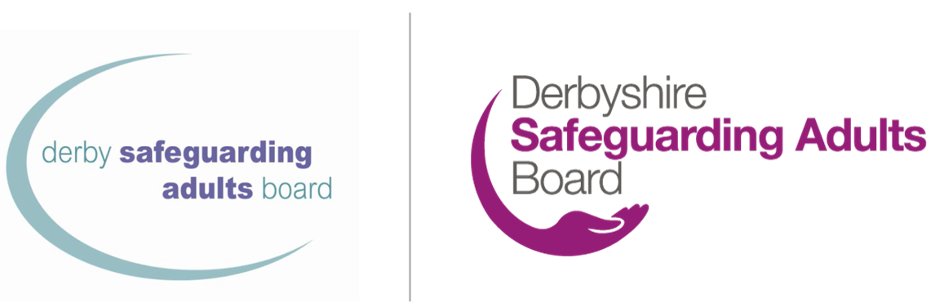

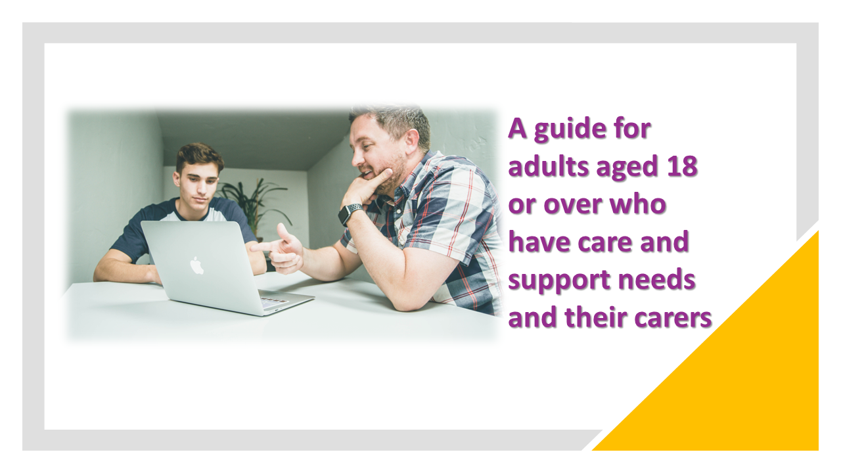

|  |  |  |
| --- | --- | --- |
| (Photo?) | | Your main point of contact for safeguarding is: (Name) |
| Phone Email | How to contact them: Call:  Email:  Emergency phone:  Out of hours phone: | | |

|  |  |
| --- | --- |
| Leaflet  neglect | Why you have been given this leaflet There are some concerns about the wellbeing of you or the person you care for. We would like to support you to stay safe. This support is called safeguarding.  Everyone has the right to live free from harm and neglect.  We may be told that a person is being hurt or abused. When there are concerns raised, we try to find out what has happened. |

|  |
| --- |
| At the moment we are concerned about: |

|  |  |
| --- | --- |
| help writing your plan  safeguarding  bad to good scale | What to expect: adult safeguarding Your wellbeing, safety and rights are important. We will talk to you about what help you need to stay safe. We might also ask others to talk to you about this.  With you and/or your carer we will make a plan to keep you safe. Other people who support you may be part of this plan. They may have jobs to do with you or for you.  You might be asked to come to a meeting about keeping you safe. You and the people who can support you will work together to help.  If you find it hard to make decisions or understand things, we will help you. We will do what’s best for you when needed.  When the safeguarding process is finished, we want to hear what you think. We’d like to know how you feel it went. |

|  |
| --- |
| People who might help to keep you safe: |

|  |  |
| --- | --- |
| write down  write down what you think | Your views/your carer’s views Please write what you think on the next page. If you are a carer, please help the person you look after fill out this part of the form. If they can’t do it themselves, you can fill it out for them.  If you like, you can share this with your main contact.  You could record:   * Your views on the risks that have been identiﬁed * What you would like to happen in future to help you keep safe * What you think local agencies can do to support you * Anything else you think the agencies should know. |

|  |
| --- |
| Write your views here (if you are a carer, please state this below): |

|  |  |
| --- | --- |
| I do understand signing  Advocate AIS  share information V2 | Your information You will be given information in a way we hope you can understand.  You will know what is happening and have your views listened to.  You can have someone of your choice to support you. This is called an advocate. They can help you share what you want to say. They will also make sure others listen to your views.   * In Derbyshire independent advocacy support is provided by [Cloverleaf Advocacy](https://cloverleaf-advocacy.co.uk/areas/derbyshire), phone 01924 454875 * In Derby City independent advocacy support is provided by [Disability Direct](https://www.disabilitydirect.com/), phone 01332 299449.   We may need to share your information with others like the NHS or the police. We will only share information when we need to and will follow the [Derbyshire County Council privacy notices](https://www.derbyshire.gov.uk/council/gdpr/privacy-notices/privacy-notices.aspx) and [Derby City Council privacy notices](https://www.derby.gov.uk/site-info/privacy-notices/about/). |

|  |  |
| --- | --- |
| contact V2 | Other contacts  * [Police](https://www.derbyshire.police.uk/) – in an emergency phone 999; non-emergency phone 101   If you're deaf, hard of hearing, or have speech difficulties, you can use [emergencySMS](http://www.emergencysms.net/" \o "emergencySMS" \t "_blank) by texting 999 from your phone, or use the [Relay UK](https://rnid.org.uk/information-and-support/technology-and-products/relay-uk/) (formerly NGT Relay Assistant) by dialling 18000 from the app or textphone.   * [Call Derbyshire](https://www.derbyshire.gov.uk/council/contact-us/call-derbyshire/call-derbyshire.aspx) – 01629 533190 * [Derby City Adult Care](https://www.derby.gov.uk/site-info/privacy-notices/about/) phone 01332 640777 * [Derby City Council Multi-Agency Safeguarding Hub (MASH)](https://www.derby.gov.uk/health-and-social-care/safeguarding-adults-at-risk/safeguarding-vulnerable-adults/#page-6) - phone 01332 642855 |

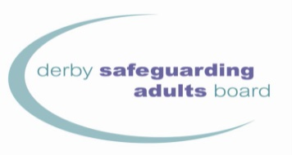

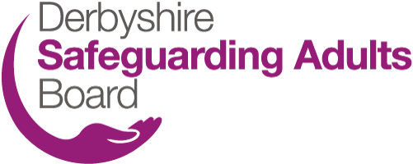

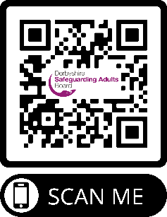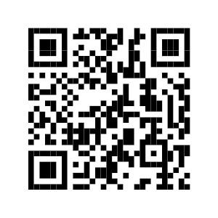

[www.derbysab.org.uk](http://www.derbysab.org.uk) [www.derbyshiresab.org.uk](http://www.derbyshiresab.org.uk)

|  |  |
| --- | --- |
| mobile phone  Internet | To use the QR codes  * Open the camera on your phone. * Hold your phone steady and point the camera at the QR code on the screen. Keep it still for a few seconds to scan. * Tap the notification that pops up to open the link. You will need to be connected to the internet to do this. |

